 | Uniform Inspection Checklist  Troop 4673 | 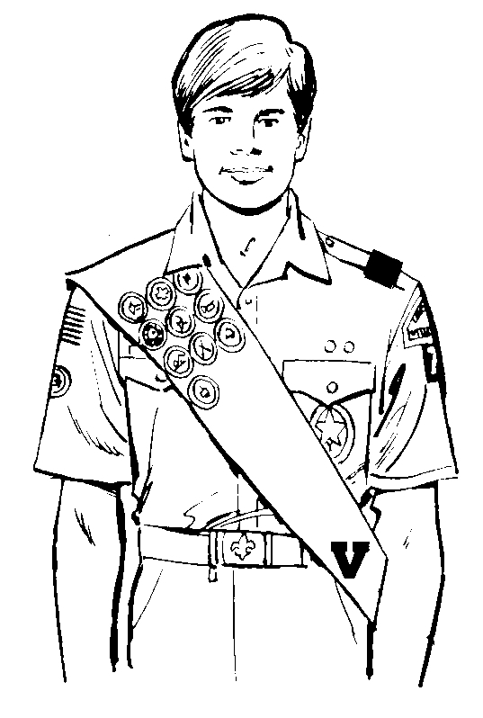

Scout Name:

Uniform Item | Passed | Failed | Not Applicable
Scout Hat: Troop Hat or Centennial Olive Green Hat.
BSA Khaki Shirt: Clean. Pressed. Tucked in to pants. No missing buttons.
Olive Green Shoulder Tabs: Worn.
Neckerchiefs: Worn folded and under the collar. No more than six inches may show (measured from the top of the collar to the end of the neckerchief).
National Capitol Area Council (NCAC) Council Emblem: Worn directly below the shoulder seam of the left shirt sleeve.
Troop Numerals '4673': Worn directly below the NCAC Emblem on the left shirt sleeve.
Trained Strip: Worn directly on the pocket flap of the left shirt sleeve (Centennial Uniform) or below the badge of office (older uniform).
Badges of Office: Worn centered on the pocket flap of the left shirt sleeve (Centennial Uniform) or just below the troop numerals (older uniform).
Shoulder Cord: Worn suspended from the top, left shoulder and strung beneath the arm. Worn only while serving in the respective office.
U.S. Flag: Worn directly below the shoulder seam of the right shirt sleeve.
Patrol Patch: Worn centered on the right shirt sleeve between the U.S. Flag and the Quality Unit Award (if earned).
Religious Emblem: A Knot Award worn centered above the left shirt pocket flush with the top of the pocket flap seam.
Badges of Rank: Rank is worn centered on the left shirt pocket, directly below the pocket flap. The WEBELOS Arrow of Light Badge is worn centered on the pocket, just beneath the lower seam of the pocket.
Recruiter Strip: Worn, if earned, centered on the right pocket, just beneath the lower seam of the pocket.
Boy Scouts of America Strip: Worn above the right shirt pocket, flush with the top of the pocket flap seam.
Order of the Arrow Lodge Flap: Worn over the right shirt pocket flap by members in good standing in the lodge.
Quality Unit Award: Prior year only (Not authorized on a jamboree uniform).
World Crest: Optional. Worn centered above the left pocket and shoulder seam and above any Service Stars.

Service Stars: Optional. Gold with numeral in center indicating years of service in scouting. Stars are worn 3/8” above the left shirt pocket seam or 3/8” above any Knot Award. A yellow backing indicates service in Cub Scouts (Tigers, Cubs, WEBELOS), green indicates service in Boy Scouts, and red backing indicates service in Venturing.

BSA Pants or Shorts: Olive Green.
BSA Socks: Olive Green (or Olive Green with Red Stripe).
Belt: Olive Green with Gold Boy Scout belt buckle (or any other Boy Scout Belt).
Temporary Insignia: Worn centered on the right shirt pocket.

Comments:

